**1 FROM BASE 2 TO 10:**

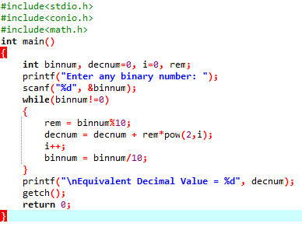

**OUTPUT:**

